**Notice : Counselling-cum-Admission against Supernumerary Self-Finance/Paid Seats in M.Com. 18 Jul, 2025**

**(Academic Session 2025-26)**

**1.** In reference to the Admission Notification for Postgraduate Programs for the Academic Session 2025-26 (Ref. No. 1-3/MGCU/CoE/2025/ CUET/PG dated June 20, 2025), admissions are being offered on the basis of CUET 2025 (PG) Score against **11 Paid Seats**. If the candidates are interested to take admission in supernumerary Self-Finance/Paid seats and have earlier applied for admissions against the advertisement (Post Graduate Programmes) issued by the University and were unable to secure admission under the regular seats are advised to appear for counselling-cum-admission to the M.Com. programme on **22 July, 2025** **(Tuesday)** **before 11:45 AM at the Department of Commerce, MGCU**.

**2.** Candidates can refer to the **Revised Guidelines and Fee Structure** for the Supernumerary Self Finance/ Paid Seats available on the link <https://mgcub.ac.in/pdf/2025071617000633d5091e4c.pdf>

**3.** Before proceeding with admission/counselling, candidates must ensure they meet the

eligibility criteria as specified in:

• The NTA Information Bulletin for CUET (PG) - 2025: <https://exams.nta.ac.in/CUETPG/images/ib-of-cuet-pg-2025.pdf>

• The MGCUB Admission Notification 2025-26: <https://mgcub.ac.in/pdf/2025051919365460888a808c.pdf>

**4**. Any updates, corrections, or additional notices related to this notification will be published exclusively on the University website: [www.mgcub.ac.in](http://www.mgcub.ac.in) . Candidates are advised to visit the site regularly for the latest information.

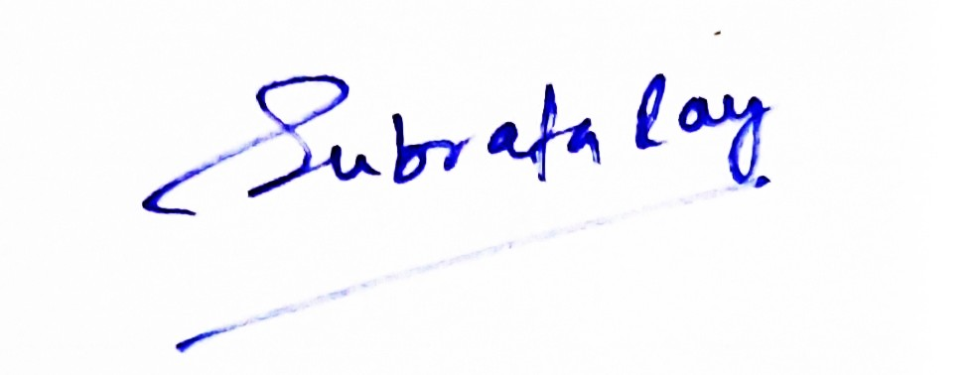

**Head, Department of Commerce**